How to do test sending PLU in DMC

      - Go to DMC, Menu > Configuration > Data Export & Import

      - Choose Store and Type as Export and click on Exec button

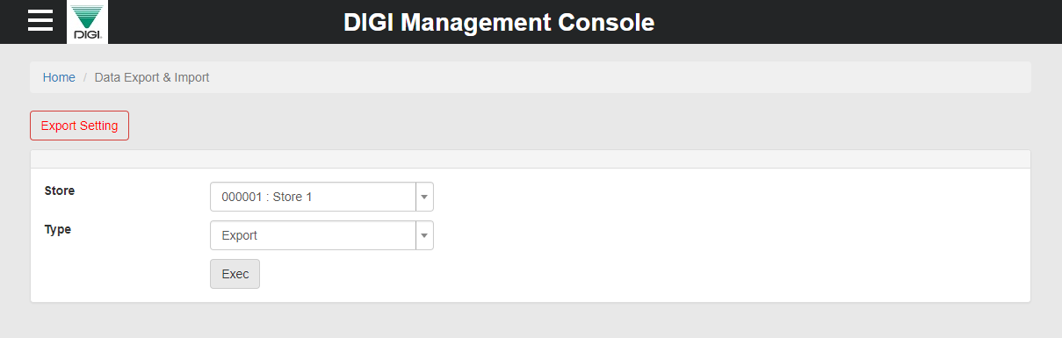

      - At Store server machine go to [Report]

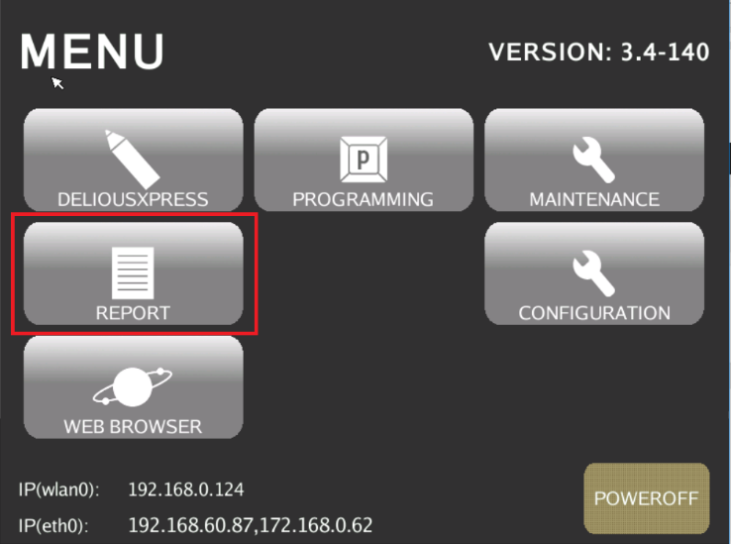

      - Tap DMC button.

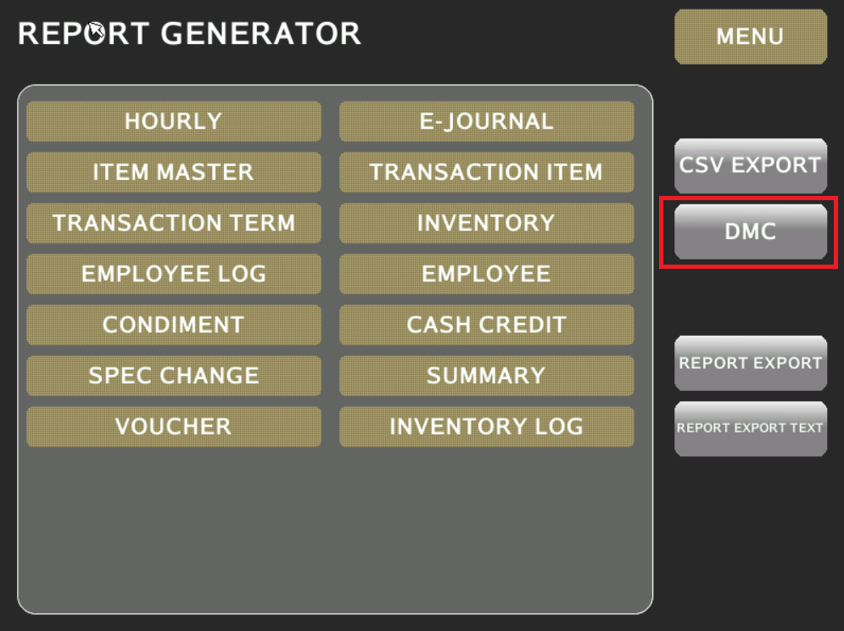

      - Tap on IMPORT and START

